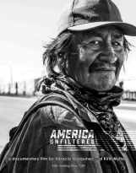
America Unfiltered A documentary film by Horacio Marquínez and Kirill Myltsev
USA English Running time 1:34
Contact information
Horacio Marquínez
hmarquinez@gmail.com
917-885-8504
Logline
Wanting to understand a fractured nation, two immigrant filmmakers embark on a cross-country listening and recording tour, revealing an unfiltered, unflinching portrait of America.
Short Description
Wanting to understand a fractured country with a rancorous election underway during a wave of gun violence, two immigrant filmmakers, one from Panama and the other from Russia, journey across the United States revealing an unfiltered, unflinching portrait of America. The filmmakers traveled for nine months in a Mini-Cooper listening to people and recording their stories about what it’s like to live in America today. America Unfiltered draws from a series of raw and emotional encounters on topics ranging from politics and gun control
1 of 5
to race and immigration. The film presents an unvarnished vision of our shared humanity and engenders hope for our country’s next chapter.
Longer Description
Wanting to understand a fractured country with a rancorous election underway during a wave of gun violence, two immigrant filmmakers, one from Panama and the other from Russia, journeyed across the United States revealing an unfiltered, unflinching portrait of America. The filmmakers traveled for nine months in a Mini-Cooper listening to people and recording their stories about what it’s like to live in America today. The film draws from a series of raw and emotional encounters unpacking people’s beliefs and hopes that both divide and unite the country under one flag. The filmmakers meet aggrieved Black mothers who lost their sons to senseless gun violence. Silent about injustice no more, they witness the strength of one family who is striving to obtain 100,000 signatures in an effort to re-open one of over 170 closed court cases. Horacio and Kirill next explore the hardscrabble realities of a rural, conservative town in Alabama facing widespread economic decline and opioid addiction. They learn the perspectives of an Afghanistan vet with PTSD and a formerly incarcerated mom struggling to raise her two children. Following their intuition, Horacio and Kirill end up in Washington, D.C. on January 6th, 2021, recording this historical day from morning till night. The filmmakers final stop was in NYC where they sought to understand the plight of undocumented immigrants who are seeking asylum in the United States. Horacio and Kirill expose the impact of the coronavirus - lost jobs, hunger, and homelessness - on this vulnerable population. America Unfiltered presents an unvarnished vision of our shared humanity and engenders hope for our country’s next chapter.
Co-Directors Statement
A few months into the Pandemic, while the film industry was shutting down, I (Horacio, a cinematographer and immigrant from Panama) and Kirill (a film
2 of 5
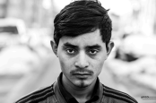
editor and immigrant from Moscow), seized the moment to fulfill our desire to drive across the United States. We wanted to meet and photograph people while listening to their stories about what it’s like to live in America today. Our vision was to invite vulnerability and capture the unfiltered narrative of the people we would encounter. We spoke to a few non-profits and philanthropists about our concept and were able to raise enough funds to cover our expenses. The two of us then hopped in my Mini-Cooper in Los Angeles and began our nine-month journey (our original plan was to shoot for two months!). In the end, we conducted over 100 in-depth interviews, filmed our travels, and shot more than 10,000 B&W portraits of people from across the country, including gun shop owners, entertainers, police officers, political activists, aggrieved moms who had lost their children to gun violence, and undocumented immigrants struggling with uncertainty and food scarcity. America Unfiltered represents our raw, unadorned emotional encounters with these people and engenders hope for a better tomorrow.
Portraits
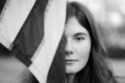
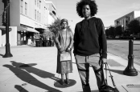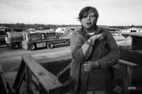3 of 5
The Filmmakers
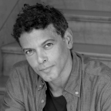
Horacio Marquínez, Co-Director, Photographer
Horacio is an award-winning director and
cinematographer who has made over 40 feature
films, numerous commercials and documentaries,
and critically acclaimed photographs. Born and
raised in Panama, Horacio made his way to NYC
graduating from Columbia University Film School.
Horacio has worked on independent films, commercials, and major motion pictures that include renowned directors, producers, and actors including Robin Williams, Adrian Brody, Joan Rivers, Vera Farmiga, Mila Jovovich, and Blythe Danner. Horacio also directed Rainbow Day Camp, a documentary film that tells the story of a summer camp for gender creative children. The film received critical acclaim and awards on the film festival circuit. Horacio also has lent his talents as a professor of cinematography at Columbia University and at UCLA and LA Film Schools. He splits his time between Los Angeles and New York.
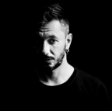
Kirill Myltsev, Co-Director, Editor
Kirill is a highly regarded network/studio editor,
originally from Moscow, Russia. He is a pioneer in his
field, combining novel editing techniques with a
more classic approach. Cannes Best Director Pavel
Lungin said, “I can wholeheartedly praise Kirill’s
wondrous film editing.” Kirill was born and raised by
loving parents in Moscow and found fun and solace in reading world literature and studying film. That early passion led him to attend and graduate with a
4 of 5
master’s degree in directing from the University of Moscow. He has edited over a dozen feature films in his native country of Russia. He arrived in the United States in 2018 and quickly made his mark editing commercials, documentaries, and narrative films. He lives in Los Angeles.
5 of 5

