4/6  How Science Powers Us - Tour of a pharmaceutical lab | 4/7  Children’s Museum of Indianapolis (Museum at Home videos) | 4/8  The Louvre in France - The Apollo Gallery | 4/9  Discover Hawaii (takes a bit to load so please be patient) | 4/10  Bryce Canyon National Park, Utah
4/13  Future U. - Visit Johnson Space Center and meet Boeing employees | 4/14  Dry Tortugas National Park, Florida | 4/15  The National Gallery, U.K | 4/16  Canadian Apple Orchard  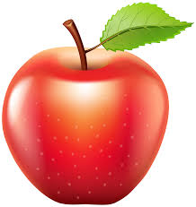 | 4/17  St. Louis Aquarium Galleries
4/20  Stanley Black and Decker Makerspace | 4/21  The Louvre in France - History of the Louvre | 4/22  Space Shuttle Discovery  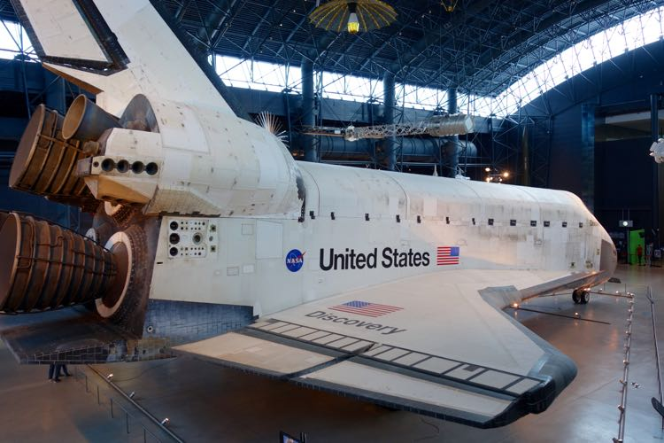 | 4/23  Carlsbad Caverns National Park, New Mexico | 4/24  National Gallery of Art, Washington, D.C.
4/27  National Museum of Modern and Contemporary Art, South Korea | 4/28  Monterey Bay Aquarium Live Animal Cams  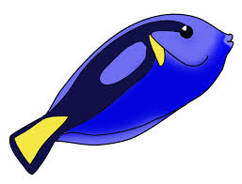 | 4/29  Hawai’i Volcanoes National Park, Hawaii | 4/30  Soar with Wings - exploring social/emotional health | 5/1  STEM Careers - Improving Animal Health

Calendar of Virtual Field Trips for Families
May 2020

Monday | Tuesday | Wednesday | Thursday | Friday
5/4  Kenai Fjords National Park, Alaska | 5/5  Van Gogh Museum, Netherlands | 5/6  Teaching with Testimony - #strongerthanhate | 5/7  Polar Bears in the Tundra  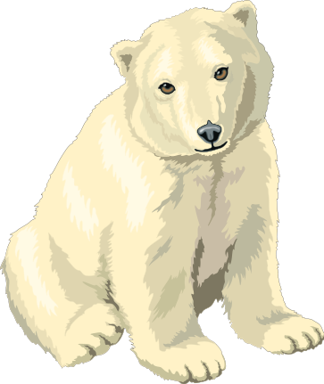 | 5/8  Careers that Count - with the NBA
5/11  Discover Your HAPPY | 5/12  Undeniably Dairy-  Visit a Dairy Farm | 5/13  J. Paul Getty Museum, California | 5/14  Yosemite National Park, California | 5/15  Technology in Agriculture - Feeding the Growing Globe
5/18  Celebrate 400 Years of Shakespeare | 5/19  Dig into Mining | 5/20  Smithsonian’s National Zoo  Webcams | 5/21  Colonial Williamsburg Webcams | 5/22  Star Atlas - explore over 60,000 stars
5/25  Memorial Day | 5/26  The Great Lakes | 5/27  Powering the Planet - Renewable Energy | 5/28  Borneo - The Symphony of the Rain Forest | 5/29  Ellis Island

